# Portal Modifications – Extend Manager Access (Learner)

## Apr 11th 2019

* Extended Manager Access is now built into the Learner Profile rather than being a separate app like in V5
* The option to extend rights to a Manager can only be made by an Administrator
* Ideally this option is set when the Manager is setup, but can be set later, however it’s best not to change this option as other features depend on it;
* Using Big Admin on the House Account, go to Facilitator Services / Learners (Add/Edit)
* Let’s add a new Manager, click on the + at the top beside the title.
* Use dummy values like _AA for all text fields so they appear at the top of the list when done, I have setup _AA as a Manager with Manager Access: Manage Programs, Manage Modules. These rights might be given to someone like Anne McCourt in the past.
* (James: these Manager Access codes are stored in the Memb table under Memb_Jobs - in this case as: 1,2 – signifying that the 2nd and 3rd option has been selected)

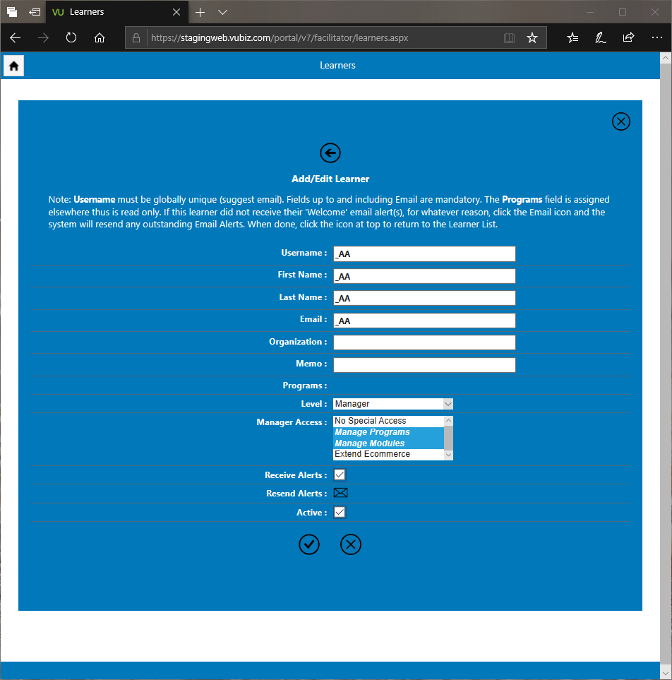

* Now, once save, exit then return and review this learner; these new values will be rendered in a more fluid manner:

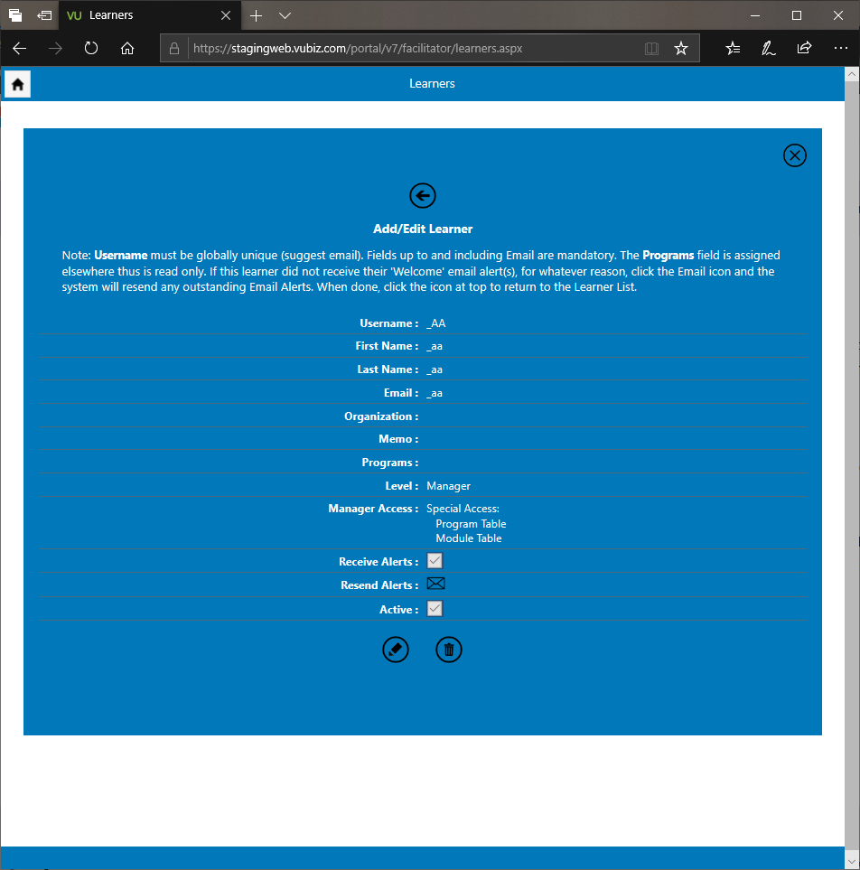

* To test, if you log out as big admin then log in as _AA / VUBZ5678 and click on the Manager Services tile, you will see two features not normally there: “Modules” and “Programs”, since we’ve extended these rights to this person. Note Modules and Programs are not done – these are placeholders.
* If you wish to add a new manager, remember to log out and sign back in as big admin?